**7)**

**Aim:**

**Basic Spring Boot Application with Spring Data JPA Description:**

In this experiment, we will create a Spring Boot application that connects to a MySQL database and uses Spring Data JPA to perform basic database operations. The application will allow inserting and retrieving student records through a RESTful API.

* **Student.java** – The entity class representing students.
* **StudentRepository.java** – The JPA repository interface for database operations.
* **StudentController.java** – REST controller for handling HTTP requests.
* **StudentApplication.java** – Main application class for bootstrapping the application.
* **application.properties** – Configuration file for database and server.
* **pom.xml** – Maven configuration file for dependencies.

# Program:

**StudentApplication.java**

package com.example;

import org.springframework.boot.CommandLineRunner; import org.springframework.boot.SpringApplication;

import org.springframework.boot.autoconfigure.SpringBootApplication; import org.springframework.context.annotation.Bean; @SpringBootApplication

public class StudentApplication {

public static void main(String[] args) { SpringApplication.*run*(StudentApplication.class, args);

}

@Bean

CommandLineRunner initDatabase(StudentRepository repo) { return args -> {

repo.save(new Student(1, "Rakesh kumar")); repo.save(new Student(2, "Murali")); repo.save(new Student(3, "vamsi")); System.*out*.println("Students inserted!");

};

}

}

# Student.java

package com.example;

import jakarta.persistence.Entity; import jakarta.persistence.Id; @Entity

public class Student {

@Id private int sno;

private String sname;

public Student() {}

public Student(int sno, String sname) { this.sno = sno;

this.sname = sname;

}

public int getSno() { return sno; }

public void setSno(int sno) { this.sno = sno; } public String getSname() { return sname; }

public void setSname(String sname) { this.sname = sname; }

}

# application.properties

spring.application.name=Student server.port= 0000

spring.datasource.url=jdbc:mysql://localhost:3306/mca spring.datasource.username=root spring.datasource.password=Yuvaraju@@2004 spring.jpa.hibernate.ddl-auto=create-drop spring.jpa.show-sql=true

# StudentController.java

package com.example; import java.util.List;

import org.springframework.web.bind.annotation.GetMapping; import org.springframework.web.bind.annotation.PostMapping; import org.springframework.web.bind.annotation.RequestBody; import org.springframework.web.bind.annotation.RestController;

@RestController

//@RequestMapping("/students") public class StudentController {

private final StudentRepository repo;

public StudentController(StudentRepository repo) { this.repo = repo;

}

//@RequestMapping("/students")

// Add new student @PostMapping

public Student addStudent(@RequestBody Student student) { return repo.save(student);

}

// Get all students @GetMapping

public List<Student> getAllStudents() { return repo.findAll();

}

}

# StudentRepository.java (Interface)

package com.example;

import org.springframework.data.jpa.repository.JpaRepository;

public interface StudentRepository extends JpaRepository<Student, Integer>{

}

# pom.xml

<?xml version="1.0" encoding="UTF-8"?>

<project xmlns="<http://maven.apache.org/POM/4.0.0>" xmlns:xsi="<http://www.w3.org/2001/XMLSchema-instance>"

xsi:schemaLocation="<http://maven.apache.org/POM/4.0.0> https://maven.apache.org/xsd/maven-4.0.0.xsd">

<modelVersion>4.0.0</modelVersion>

<parent>

<groupId>org.springframework.boot</groupId>

<artifactId>spring-boot-starter-parent</artifactId>

<version>3.5.4</version>

<relativePath/> <!-- lookup parent from repository -->

</parent>

<groupId>com</groupId>

<artifactId>StudentApplication</artifactId>

<version>0.0.1-SNAPSHOT</version>

<name>Student</name>

<description>Demo project for Spring Boot</description>

<url/>

<licenses>

<license/>

</licenses>

<developers>

<developer/>

</developers>

<scm>

</scm>

<connection/>

<developerConnection/>

<tag/>

<url/>

<properties>

<java.version>21</java.version>

</properties>

<dependencies>

<dependency>

<groupId>org.springframework.boot</groupId>

<artifactId>spring-boot-starter-data-jdbc</artifactId>

</dependency>

<dependency>

<groupId>org.springframework.boot</groupId>

<artifactId>spring-boot-starter-web</artifactId>

</dependency>

<dependency>

<groupId>com.mysql</groupId>

<artifactId>mysql-connector-j</artifactId>

<scope>runtime</scope>

</dependency>

<dependency>

<groupId>org.springframework.boot</groupId>

<artifactId>spring-boot-starter-test</artifactId>

<scope>test</scope>

</dependency>

<!-- https://mvnrepository.com/artifact/org.springframework.boot/spring-boot- starter-data-jpa -->

<dependency>

<groupId>org.springframework.boot</groupId>

<artifactId>spring-boot-starter-data-jpa</artifactId>

<version>3.5.2</version>

</dependency>

</dependencies>

<build>

<plugins>

<plugin>

<groupId>org.springframework.boot</groupId>

<artifactId>spring-boot-maven-plugin</artifactId>

</plugin>

</plugins>

</build>

</project>

**Output:**

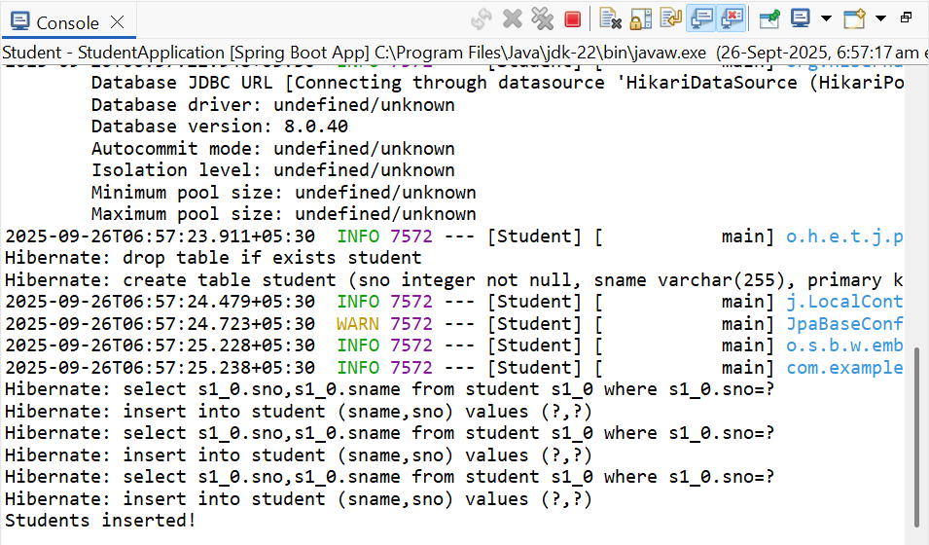

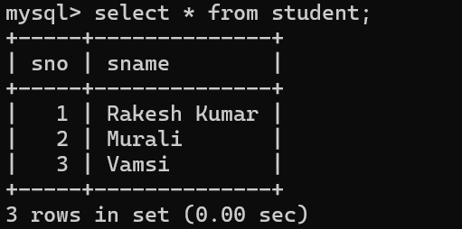

**8)**

**Aim:**

**Pagination and Sorting in Spring Data JPA Description:**

In this experiment, we will create a Spring Boot application that demonstrates how to paginate and sort database records using Spring Data JPA. We will use a Book entity with sample data, a JPA repository interface for database operations, and a REST controller to handle requests. Pagination parameters (page, size) and sorting parameters (sortBy, direction) will be passed via URL query parameters to retrieve data in a paginated and sorted manner.

# Program: application.properties

spring.application.name=Book spring.datasource.url=jdbc:mysql://localhost:3306/new spring.datasource.username=root spring.datasource.password=Yuvaraju@@2004 spring.jpa.hibernate.ddl-auto=create-drop spring.jpa.show-sql=true

server.port=0000

# BookApplication.java

package com.example.demo;

import org.springframework.boot.SpringApplication;

import org.springframework.boot.autoconfigure.SpringBootApplication;

@SpringBootApplication public class BookApplication {

public static void main(String[] args) { SpringApplication.*run*(BookApplication.class, args);

}

}

# Book.java

package com.example.demo; import jakarta.persistence.Entity;

import jakarta.persistence.GeneratedValue; import jakarta.persistence.GenerationType; import jakarta.persistence.Id;

@Entity

public class Book { @Id

@GeneratedValue(strategy = GenerationType.*IDENTITY*) private long id;

private String title; private String author;

public Book() {}

public Book(String title, String author) { this.title = title;

this.author = author;

}

@Override

public String toString() {

return "Book{id=" + id + ", title='" + title + "', author='" + author + "'}";

}

// getters and setters

public Long getId() { return id; }

public void setId(Long id) { this.id = id; }

public String getTitle() { return title; }

public void setTitle(String title) { this.title = title; }

public String getAuthor() { return author; }

public void setAuthor(String author) { this.author = author; }

}

# BookRepository (Interface)

package com.example.demo;

import org.springframework.data.jpa.repository.JpaRepository;

public interface BookRepository extends JpaRepository<Book, Long>{

}

# BookController.java

package com.example.demo;

import org.springframework.beans.factory.annotation.Autowired; import org.springframework.data.domain.Page;

import org.springframework.data.domain.PageRequest; import org.springframework.data.domain.Pageable; import org.springframework.data.domain.Sort;

import org.springframework.web.bind.annotation.*; @RestController

@RequestMapping("/books") public class BookController {

@Autowired

private BookRepository bookRepository; @GetMapping("/init")

public String initData() {

if (bookRepository.count() == 0) {

bookRepository.save(new Book("Spring Boot Basics", "John")); bookRepository.save(new Book("Java Programming", "Alice")); bookRepository.save(new Book("Hibernate in Action","Bob")); bookRepository.save(new Book("Microservices Guide", "Carol")); bookRepository.save(new Book("Data Structures", "Davidraj"));}

return "Sample books added!";

}

@GetMapping

public Page<Book> getBooks( @RequestParam(defaultValue = "0") int page, @RequestParam(defaultValue = "3") int size, @RequestParam(defaultValue = "title") String sortBy, @RequestParam(defaultValue = "asc") String direction

) {

Sort sort = direction.equalsIgnoreCase("asc") ?

Sort.*by*(sortBy).ascending() : Sort.*by*(sortBy).descending();

Pageable pageable = PageRequest.*of*(page, size, sort); return bookRepository.findAll(pageable);

}

}

# pom.xml

<?xml version="1.0" encoding="UTF-8"?>

<project xmlns="<http://maven.apache.org/POM/4.0.0>" xmlns:xsi="<http://www.w3.org/2001/XMLSchema-instance>" xsi:schemaLocation="<http://maven.apache.org/POM/4.0.0>

https://maven.apache.org/xsd/maven-4.0.0.xsd">

<modelVersion>4.0.0</modelVersion>

<parent>

<groupId>org.springframework.boot</groupId>

<artifactId>spring-boot-starter-parent</artifactId>

<version>3.5.6</version>

<relativePath/> <!-- lookup parent from repository -->

</parent>

<groupId>com</groupId>

<artifactId>PaginationandSortingApplication</artifactId>

<version>0.0.1-SNAPSHOT</version>

<name>Book</name>

<description>Demo project for Spring Boot</description>

<licenses>

<license/>

</licenses>

<developers>

<developer/>

</developers>

<scm>

<connection/>

<developerConnection/>

<tag/>

<url/>

</scm>

<properties>

<java.version>21</java.version>

</properties>

<dependencies>

<dependency>

<groupId>org.springframework.boot</groupId>

<artifactId>spring-boot-starter-data-jdbc</artifactId>

</dependency>

<dependency>

<groupId>org.springframework.boot</groupId>

<artifactId>spring-boot-starter-web</artifactId>

</dependency>

<dependency>

<groupId>com.mysql</groupId>

<artifactId>mysql-connector-j</artifactId>

<scope>runtime</scope>

</dependency>

<dependency>

<groupId>org.springframework.boot</groupId>

<artifactId>spring-boot-starter-test</artifactId>

<scope>test</scope>

</dependency>

<dependency>

<groupId>org.springframework.boot</groupId>

<artifactId>spring-boot-starter-data-jpa</artifactId>

</dependency>

</dependencies>

<build>

<plugins>

<plugin>

<groupId>org.springframework.boot</groupId>

<artifactId>spring-boot-maven-plugin</artifactId>

</plugin>

</plugins>

</build>

</project>

**Output:**

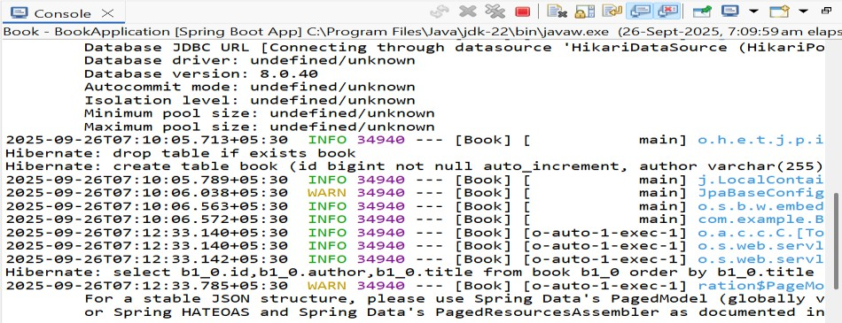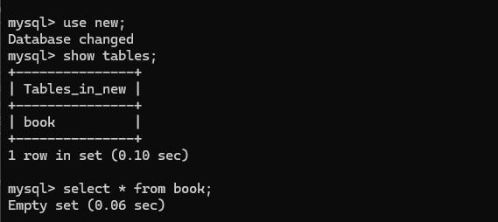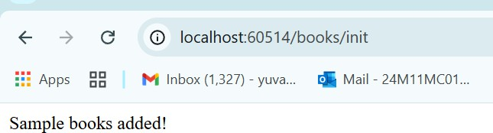

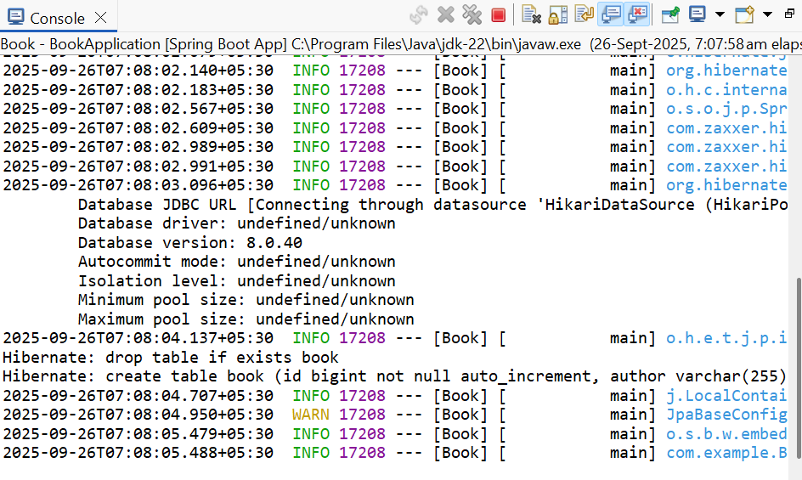

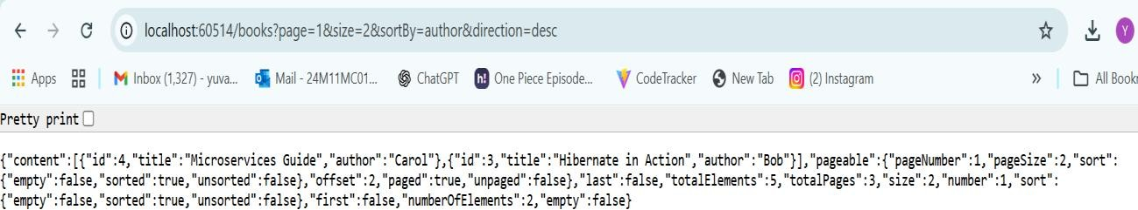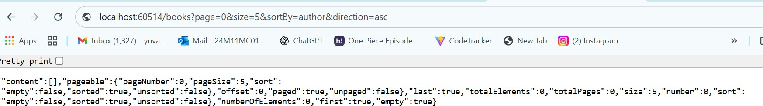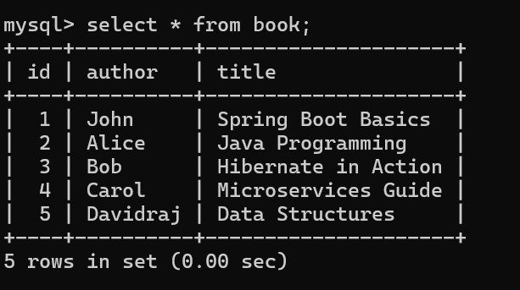



**9)**

**Aim:**

**Implementing AOP for Logging with Spring Data JPA Description:**

In this experiment, we create a Spring Boot application to manage products. The application includes:

* **Entity** – Product with id, name, and price.
* **Repository** – ProductRepository for database operations.
* **Service** – ProductService to handle business logic.
* **Controller** – ProductController for REST APIs.
* **Aspect** – LoggingAspect to log method calls in ProductService.
* **Database** – H2 in-memory DB or MySQL.
* **Dependency Management** – Managed via Maven (pom.xml).

This demonstrates the use of **Spring Data JPA**, **Spring AOP**, and **RESTful API development**.

# Program:

**ProductRepository.java (Interface)**

**package** com.example.demo;

**import** org.springframework.data.jpa.repository.JpaRepository;

**public interface** ProductRepository **extends** JpaRepository<Product, Long> {

}

# ProductService.java

package com.example.demo;

import org.springframework.stereotype.Service; import java.util.List;

@Service

public class ProductService {

private final ProductRepository repo;

public ProductService(ProductRepository repo) { this.repo = repo;

}

public Product saveProduct(Product product) { return repo.save(product);

}

public List<Product> getAllProducts() { return repo.findAll();

}

}

**application.properties** spring.application.name=product spring.datasource.url=jdbc:mysql://localhost:3306/yuvi spring.datasource.username=root spring.datasource.password=Yuvaraju@@2004 spring.jpa.hibernate.ddl-auto=create-drop spring.jpa.show-sql=true

server.port=0000

# Product.java

package com.example.demo; import jakarta.persistence.Entity;

import jakarta.persistence.GeneratedValue; import jakarta.persistence.GenerationType; import jakarta.persistence.Id;

@Entity

public class Product { @Id

@GeneratedValue(strategy = GenerationType.IDENTITY) private long id;

private String name; private double price; public Product() {}

public Product(String name, double price) { this.name = name;

this.price = price;

}

// getters & setters

public Long getId() { return id; }

public void setId(Long id) { this.id = id; } public String getName() { return name; }

public void setName(String name) { this.name = name; } public double getPrice() { return price; }

public void setPrice(double price) { this.price = price; }

}

# ProductController.java

package com.example.demo;

import org.springframework.web.bind.annotation.*; import java.util.List;

@RestController @RequestMapping("/products") public class ProductController {

private final ProductService service;

public ProductController(ProductService service) { this.service = service;

}

@PostMapping("/add")

public Product addProduct(@RequestBody Product product) { return service.saveProduct(product);

}

@GetMapping("/all")

public List<Product> getAllProducts() { return service.getAllProducts();

}

}

# LoggingAspect.java

package com.example.demo; import org.aspectj.lang.JoinPoint;

import org.aspectj.lang.annotation.Aspect; import org.aspectj.lang.annotation.Before;

import org.springframework.stereotype.Component;

@Aspect @Component

public class LoggingAspect {

// Logs before executing any ProductService method @Before("execution(* com.example.demo.ProductService.*(..))") public void logBefore(JoinPoint joinPoint) {

System.out.println(">>> Entering method: " + joinPoint.getSignature().getName());

}

}

# main.java

package com.example.demo;

import org.springframework.boot.CommandLineRunner; import org.springframework.boot.SpringApplication;

import org.springframework.boot.autoconfigure.SpringBootApplication; import org.springframework.context.annotation.Bean; @SpringBootApplication

public class ProductApplication {

public static void main(String[] args) { SpringApplication.*run*(ProductApplication.class, args);

}

@Bean

CommandLineRunner runner(ProductRepository repo) { return args -> {

repo.save(new Product("Laptop", 55000));

repo.save(new Product("Mobile", 20000));

repo.save(new Product("Tablet", 30000));

repo.save(new Product("Mouse", 35000));

};

}

}

# pom.xml

<?xml version="1.0" encoding="UTF-8"?>

<project xmlns="<http://maven.apache.org/POM/4.0.0>" xmlns:xsi="<http://www.w3.org/2001/XMLSchema-instance>"

xsi:schemaLocation="<http://maven.apache.org/POM/4.0.0> https://maven.apache.org/xsd/maven-4.0.0.xsd">

<modelVersion>4.0.0</modelVersion>

<parent>

<groupId>org.springframework.boot</groupId>

<artifactId>spring-boot-starter-parent</artifactId>

<version>3.5.4</version>

<relativePath/> <!-- lookup parent from repository -->

</parent>

<groupId>com</groupId>

<artifactId>productApplication</artifactId>

<version>0.0.1-SNAPSHOT</version>

<name>product</name>

<description>Demo project for Spring Boot</description>

<url/>

<licenses>

<license/>

</licenses>

<developers>

<developer/>

</developers>

<scm>

<connection/>

<developerConnection/>

<tag/>

<url/>

</scm>

<properties>

<java.version>21</java.version>

</properties>

<dependencies>

<dependency>

<groupId>org.springframework.boot</groupId>

<artifactId>spring-boot-starter-data-jdbc</artifactId>

</dependency>

<dependency>

<groupId>org.springframework.boot</groupId>

<artifactId>spring-boot-starter-web</artifactId>

</dependency>

<dependency>

<groupId>com.mysql</groupId>

<artifactId>mysql-connector-j</artifactId>

<scope>runtime</scope>

</dependency>

<dependency>

<groupId>org.springframework.boot</groupId>

<artifactId>spring-boot-starter-test</artifactId>

<scope>test</scope>

</dependency>

<!-- Spring AOP -->

<dependency>

<groupId>org.springframework.boot</groupId>

<artifactId>spring-boot-starter-aop</artifactId>

</dependency>

<!-- Lombok (optional, just to reduce boilerplate) -->

<dependency>

<groupId>org.projectlombok</groupId>

<artifactId>lombok</artifactId>

<optional>true</optional>

</dependency>

<dependency>

<groupId>org.springframework.boot</groupId>

<artifactId>spring-boot-starter-data-jpa</artifactId>

</dependency>

<!-- H2 Database (in-memory, no need for MySQL setup) -->

<dependency>

<groupId>com.h2database</groupId>

<artifactId>h2</artifactId>

<scope>runtime</scope>

</dependency>

</dependencies>

<build>

<plugins>

<plugin>

<groupId>org.springframework.boot</groupId>

<artifactId>spring-boot-maven-plugin</artifactId>

</plugin>

</plugins>

</build>

</project>

**Output:**

